School of Computer Science and Artificial Intelligence

Lab Assignment # 6.5

Program : B. Tech (CSE)
Specialization : AIML
Course Title : AI Assisted Coding Course Code:
23CS002PC304
Semester : VI
Academic Session : 2025-2026
Name of Student : Nitesh Kumar
Enrollment No. : 2303A52098 Batch No. : 33
Date : 30/01/26

Learning Objectives
- LO1: Use AI-based code completion tools to generate Python code involving classes, loops, and conditionals.
- LO2: Interpret and explain AI-generated code line-by-line.
- LO3: Identify errors, inefficiencies, or logical flaws in AI-suggested implementations.
- LO4: Optimize AI-generated code for better readability and performance.
- LO5: Demonstrate ethical and responsible use of AI tools in coding tasks.

Task Description #1: AI-Based Code Completion for Conditional Eligibility Check
Prompt Used
“Generate Python code to check voting eligibility based on age and citizenship.”

CODE:
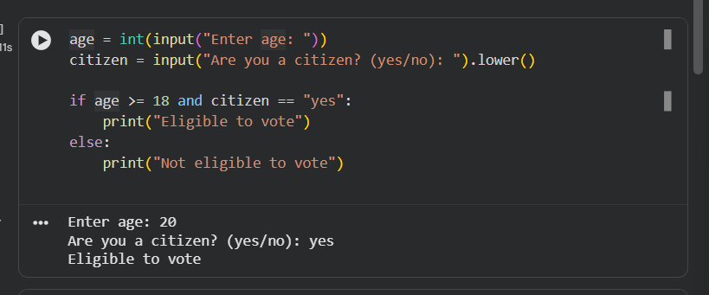
Explanation
- age >= 18 → checks minimum voting age
- citizen == "yes" → ensures citizenship
- and → both conditions must be true
- Output correctly displays eligibility
Verification
Age | Citizenship | Output
20 | yes | Eligible
16 | yes | Not Eligible
25 | no | Not Eligible

Task Description #2: AI-Based Code Completion for Loop-Based String Processing
Prompt Used
“Generate Python code to count vowels and consonants in a string using a loop.”

CODE:
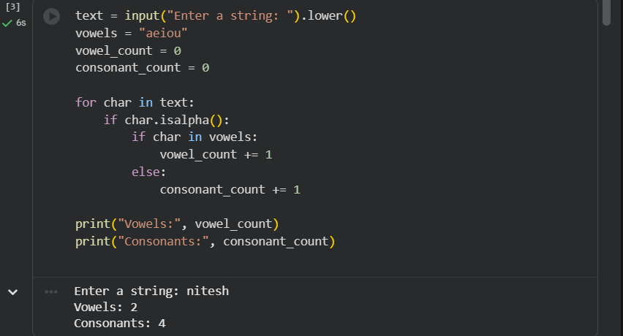

Explanation
- for char in text → loops through characters
- isalpha() → ignores spaces and symbols
- Counts vowels and consonants separately
Output Verification
Input: Hello World
Output:
Vowels: 3
Consonants: 7

Task Description #3: AI-Assisted Code Completion Reflection Task
Prompt Used
“Generate a Python program for a library management system using classes, loops, and conditional statements.”

CODE:
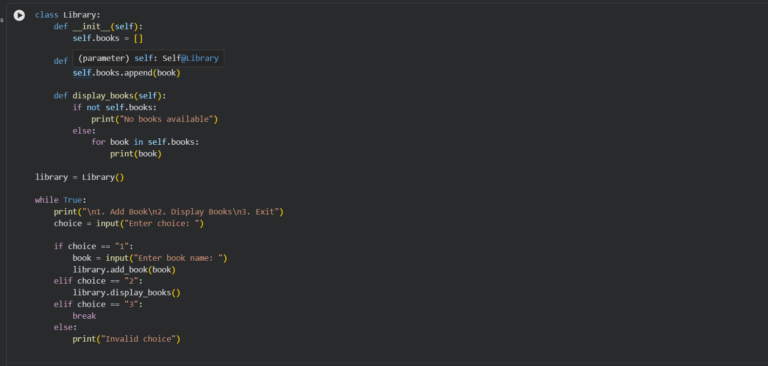

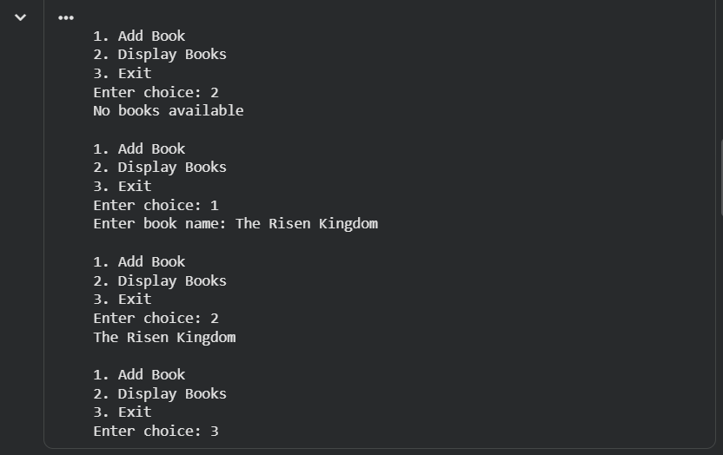

Review of AI Suggestions
- Correct use of class
- Uses loop & conditionals
- Easy to understand
- No delete/search feature (can be improved)
Reflection on AI-Assisted Coding
AI-based code completion helps in quickly generating working code structures. However, the programmer must review logic, handle edge cases, and optimize performance. AI should be used as a support tool, not a replacement for logical thinking.

Task Description #4: AI-Assisted Code Completion for Class-Based Attendance System
Prompt Used
“Generate a Python class to mark and display student attendance using loops.”

CODE:
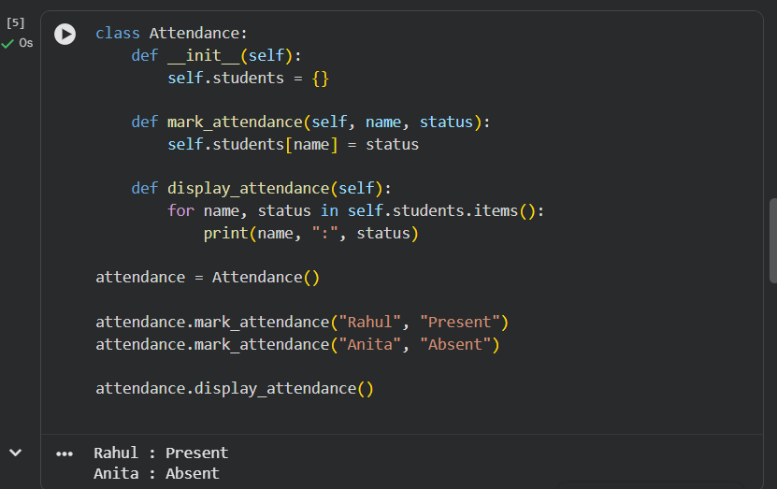

Test Case
- Adding new student → ✔ Works
- Display attendance → ✔ Correct

Task Description #5: AI-Based Code Completion for Conditional Menu Navigation
Prompt Used
“Generate a Python program using loops and conditionals to simulate an ATM menu.”

CODE:

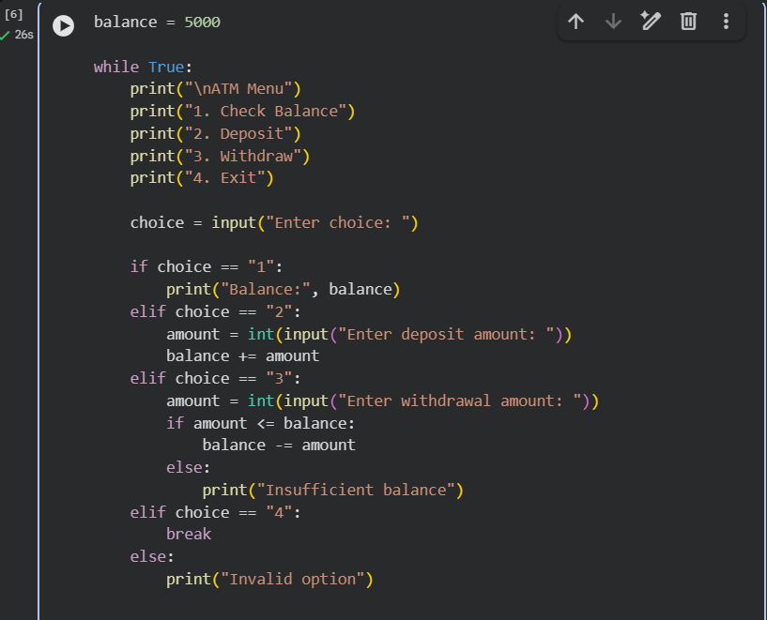

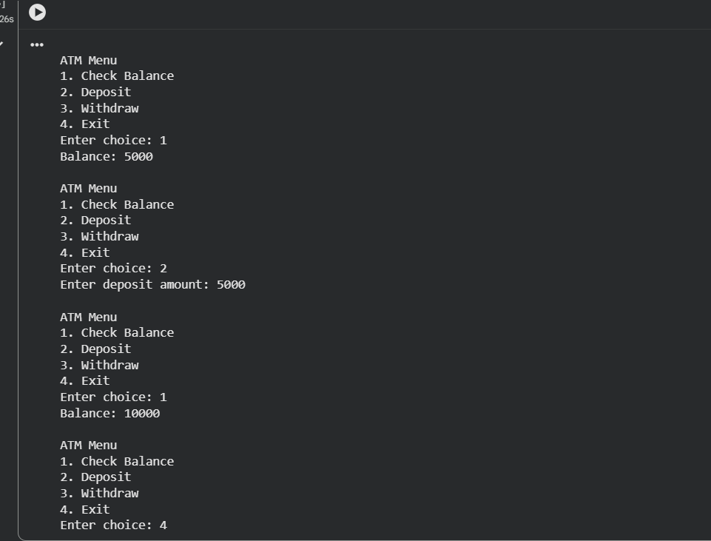

Output Verification
- Balance check → ✔
- Deposit → ✔
- Withdraw with limit → ✔

Ethical & Responsible Use of AI (LO5)
- AI-generated code was reviewed and understood
- Logic errors and improvements were identified
- AI used as a learning aid, not for blind copying
- Code explanations ensured conceptual clarity

Conclusion
This experiment demonstrated the effective use of AI-based code completion for Python programming involving classes, loops, and conditionals. AI tools improve productivity but must be used responsibly with human judgment.

